Billing Export - GCP Step-by-Step to Export SKU-Level Usage Billing

Prerequisites (Ensure Smooth Operation Without Permissions/Function Issues)
- Permission Verification:To view and download SKU billing data for your own project, your GCP account requires the Billing Viewer role at the project level.
  - To access cross-project billing account-level SKU data, you need the Billing Account Viewer role (assigned by an administrator via the IAM Console).

- Feature Availability Check:This method is suitable for quickly exporting small-scale aggregated SKU data (e.g., monthly reconciliation, basic usage verification) and supports data from the past 13 months.
  - For data older than 13 months or resource-level details (e.g., SKU usage tied to specific instance IDs), use the BigQuery Export method (see supplementary notes below).

Detailed Export Steps (Including Filtering & Download Workflow)
- Access the Billing Report Page
  - Log in to the GCP Console (console.cloud.google.com), enter "Billing" in the top search bar, and select the Cloud Billing service.
  - If your account is linked to multiple billing accounts, use the top dropdown menu to select the target billing account (ensure data corresponds to the correct account).
  - In the left navigation pane, click Report to enter the billing report visualization page.

- Configure SKU Grouping & Time Range
  - Grouping Setup: Locate the "Grouped by" dropdown at the top of the page and select SKU—the report will automatically aggregate data by "SKU Name + SKU ID", with each row representing aggregated usage/cost for a single SKU.
  - Time Range Selection: Click the time filter at the top, select Last month directly, or manually set a custom date range (e.g., "2025-10-01 to 2025-10-31"). The report will refresh in real time to display SKU data for the selected period.
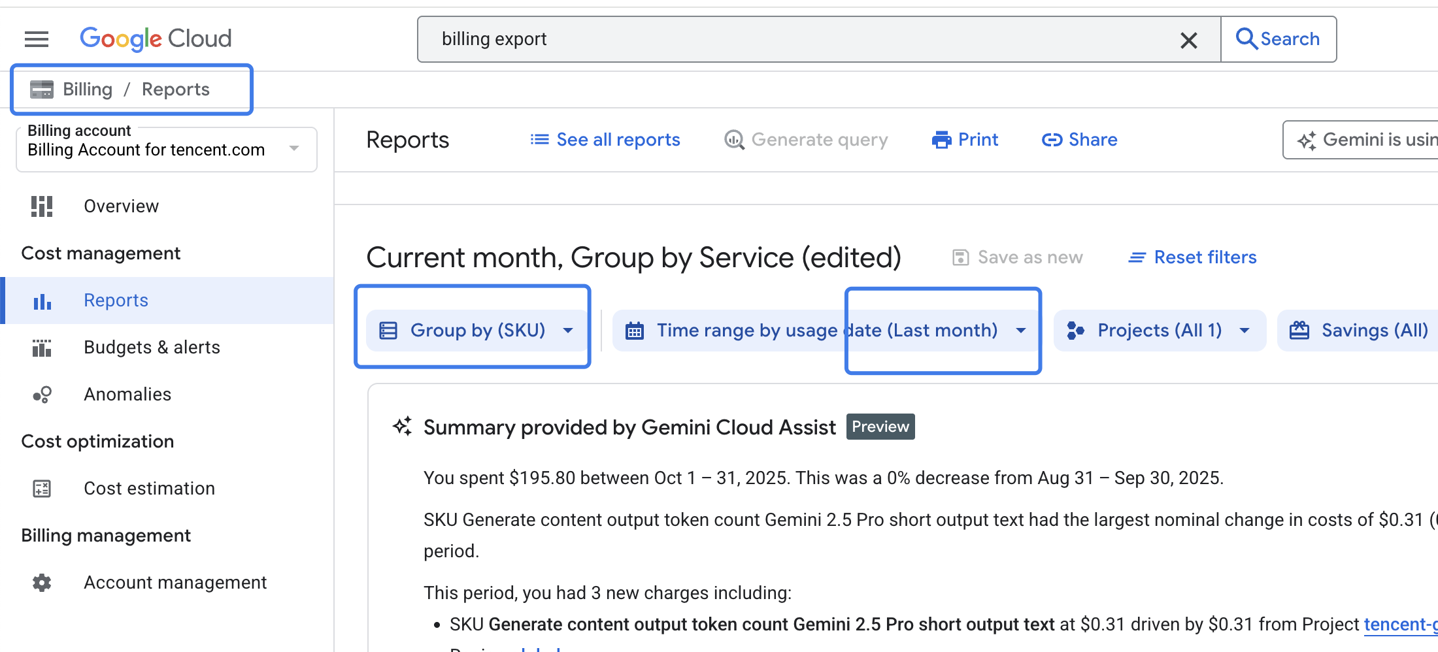

- (Optional) Precisely Filter Target SKU Data (Avoid Redundant Exports)
  - To export only SKU data for specific services, regions, or projects, use the filters in the left pane:Filter by Service: Check target services (e.g., "Compute Engine", "Cloud Storage", "GKE Autopilot") to display only SKUs under those services.
    - Filter by Region: Check target regions (e.g., "asia-southeast2 (Jakarta)", "us-central1") to focus on SKU usage in specific geographic areas.
    - Filter by Project: If the billing account has multiple projects, check the target project to export only its SKU data.
    - Filter by Cost Type: Select options like "Total Cost", "Discounted Cost", or "Tax" to export cost data for specific dimensions.

- Download SKU Billing as a CSV File
  - Verify the report data (cross-check SKU description, usage, cost, etc.). Locate the Download button in the top-right corner of the report (icon: downward arrow; tooltip: "Download CSV").
  - Click the button—GCP will automatically generate and download a CSV file to your local device. The default file includes core fields:SKU ID, SKU Description, Service Name, Region, Project ID, Project Name, Usage Amount, Usage Unit, Cost (Discounted), Total Cost (Pre-Discount), Discount Amount, Tax, etc.
  - The file can be directly used for Excel reconciliation or data analysis.
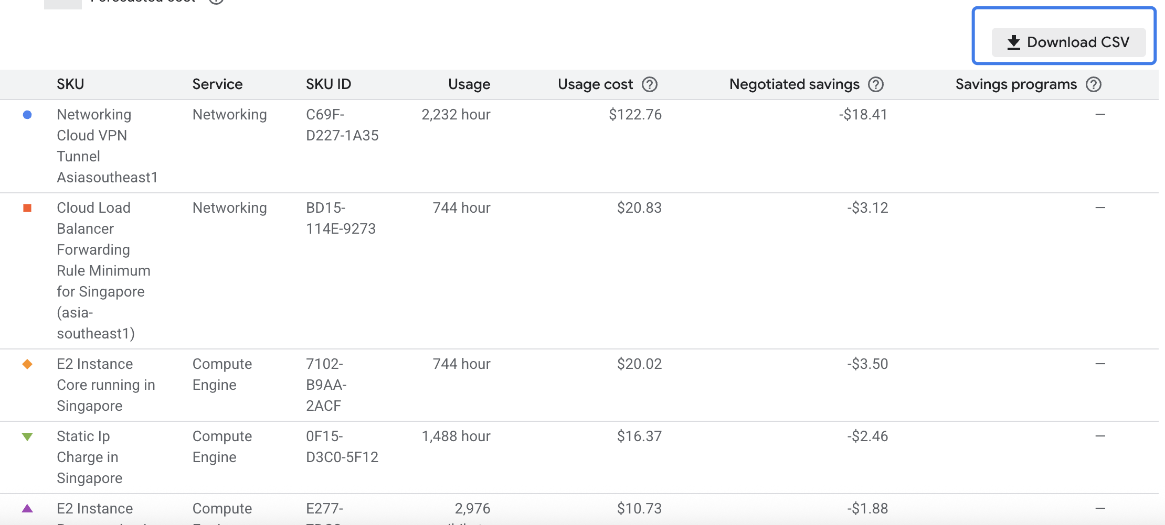

III. Key Notes (Avoid Data Discrepancies or Download Failures)
- Data Granularity:This method exports aggregated SKU-level data (e.g., total monthly usage and cost for a SKU), not "hourly/minutely usage details". For granular analysis (e.g., investigating sudden spikes in daily SKU usage), switch to BigQuery Export.

- Field Definitions:"Usage Amount": SKU usage volume (unit varies by SKU, e.g., "millicore-hours" for mCPU, "GB-months" for storage).
  - "Cost": Discounted actual cost (consistent with the "COST" column in billing statements).
  - "Total Cost": Pre-discount cost. Filter fields as needed for analysis.

- Download Limits:A single CSV export supports up to 10,000 rows. If the billing account has over 10,000 SKUs (e.g., multi-project/multi-service scenarios):Split exports using filters (e.g., export by service/region separately), or use BigQuery Export for complete data.

- Data Update Latency:Billing data typically has a 24–48-hour delay. For "real-time monthly data", recent 1–2 days of details may be missing. For monthly reconciliation, export after the 3rd day of the next month to ensure data completeness.

